

NATIONAL UNIVERSITY OF TECHNOLOGY
(Department of Computer Science)
CS161– Database Systems
Instructor: Noushin Saba
Name: Bisma Fatima
Roll no: F24605036

LAB TASK 06

In Lab Tasks

A hospital maintains records of patients, doctors, and appointments. Patients can book multiple
appointments with different doctors. Each doctor specializes in a specific department and can
have multiple appointments. An appointment includes details such as date, time, and diagnosis.
Entities and Attributes
1. Patient (patientID, name, age, contact, address)
2. Doctor (doctorID, name, specialization, contact)
3. Appointment (appointmentID, patientID (FK), doctorID (FK), date, time, diagnosis)
4. Department (deptID, name)
Relationships and Cardinality
1. A Patient can have multiple Appointments, and each Appointment is linked to one Patient (1:M).
2. A Doctor can have multiple Appointments, and each Appointment is linked to one Doctor (1:M).
3. Since a Patient can consult multiple Doctors, and a Doctor can treat multiple Patients, the Many-to-Many (M:N) relationship is resolved through the Appointment table, which connects Patients and Doctors via Foreign Keys (FKs).
4. Each Doctor belongs to one Department, but a Department can have many Doctors (1:M).

Task 1
Draw the ERD (Crow’s Foot Notation) for the above scenario.
• Include entities, attributes, and relationships.
• Show Many-to-Many (M:N) relationship between Patients and Doctors using the Appointment table.
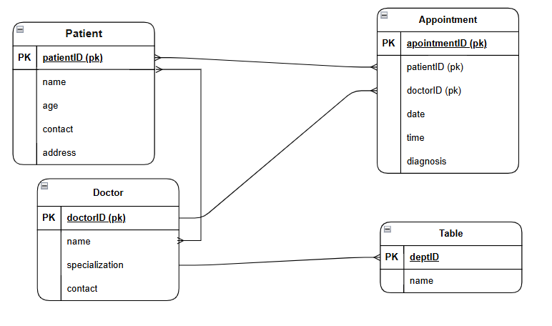

Task 2
Apply Structural Constraints
• Mandatory vs. Optional Participation: A Patient must have at least one Appointment, but a Doctor may have zero if they are new.
• Cardinality: One Appointment is linked to one Patient and one Doctor (1:M relationships).
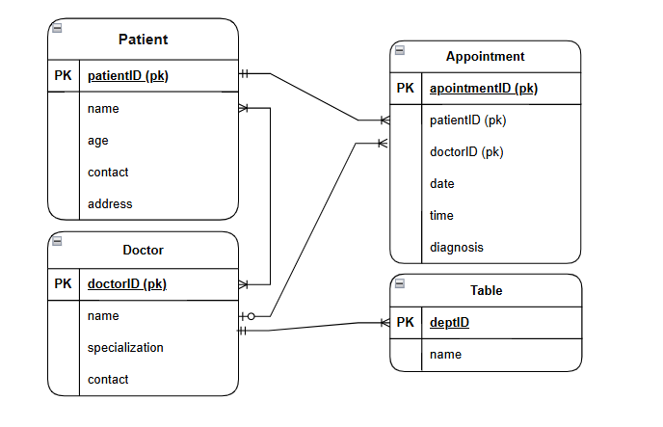

Post Lab Tasks

Task 1
Draw ERD for the above scenario using Chen’s Notation.
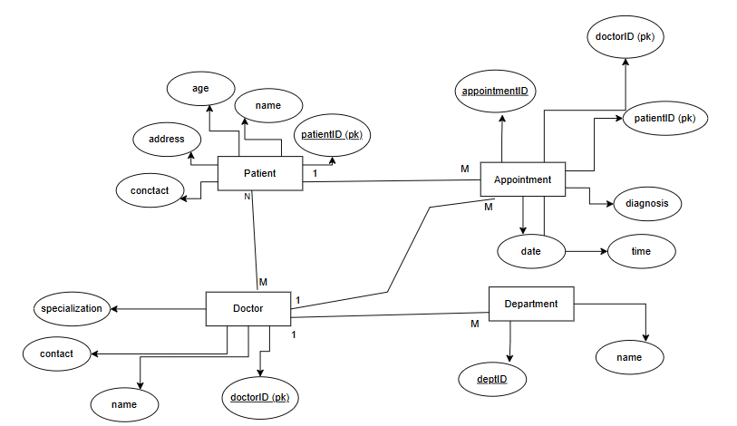
Lifelong Learning Component
How can your understanding of Entity-Relationship Modeling (ERM) help you design efficient
databases in real-world applications, adapt to different database technologies (SQL vs.
NoSQL), and overcome challenges in database design? Additionally, what steps will you take
to further improve your database modeling skills beyond this lab?

Designing Efficient Databases
1. Clear data structure: ERM helps you visualize the data structure, ensuring a clear understanding of entities, attributes, and relationships.
2. Data normalization: ERM enables you to normalize data, reducing data redundancy and improving data integrity.
3. Scalability: A well-designed ERM model allows for easy scalability, accommodating growing data volumes and changing requirements.

Adapting to Different Database Technologies
1. SQL databases: ERM is particularly useful for designing relational databases, which are based on SQL.
2. NoSQL databases: While NoSQL databases have different data models, ERM can still be applied to design the data structure and relationships.
3. Data modeling for Big Data: ERM can be adapted for Big Data applications, such as Hadoop and Spark, by focusing on data entity relationships and data flow.

Overcoming Challenges in Database Design
1. Data complexity: ERM helps you break down complex data into manageable entities and relationships.
2. Data inconsistencies: ERM ensures data consistency by defining relationships and constraints.
3. Performance optimization: A well-designed ERM model can help optimize database performance by reducing data redundancy and improving query efficiency.

Steps to Further Improve Database Modeling Skills
1. Practice with real-world scenarios: Apply ERM to real-world projects or case studies to deepen your understanding.
2. Study advanced database concepts: Explore topics like data warehousing, data mining, and database security.
3. Learn different database management systems: Familiarize yourself with various DBMS, such as MySQL, PostgreSQL, MongoDB, and Cassandra.
4. Participate in online communities and forums: Engage with other database professionals to stay updated on best practices and new technologies.
5. <small>Read books and research papers</small>: Stay current with the latest research and developments in database modeling and management.

